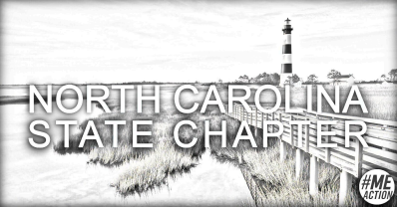#MEAction NC
Virtual ME/CFS Support Meeting
3rd Wednesday of each month at 12:30 PM Eastern US
People with ME/CFS, Long Covid, PEM/PESE, and allies are invited, whether you need support or wish to give it. We help each other cope & exchange resources as we navigate this disease.
2026 Meetings:
Jan 21, Feb 18, Mar 18, Apr 15, May 20, June 17,
July 15, Aug 19, Sept 16, Oct 21, Nov 18, Dec 16.
Virtual Advocacy
We welcome support meeting members and volunteers throughout NC and neighboring states with a wide variety of lived experience as patients or allies to follow up on petitions or other easy ideas mentioned at support meetings and on our social media. Whether you’re a pro or you’ve never volunteered before, we appreciate your help to make a difference in the lives of people with ME/CFS. Separate 2026 Advocacy Meetings are suspended until we have more capacity.

Links & info on all meetings are at linktr.ee/meactionNC.
Connect with us @MEActionNC on

Email us at: northcarolina@meaction.net

