How to Access the ACT Discussion Board?
The ACT Discussion Forum was designed to be a place for ACT listserv members to have more dialogue and exchanges. All listserv members will be “moved in” as a Discussion Forum subscriber. However, to access the Forum, you need to first establish a password.
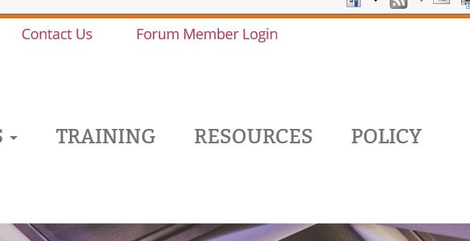
Step 1: Visit this link: http://www.institutebestpractices.org/community/?wpforo=signin
Or you can get to the same location through our Institute homepage by clicking “Forum Member Login” in the upper right corner (visual pic to the right) and it should take you to a screen like the one below.
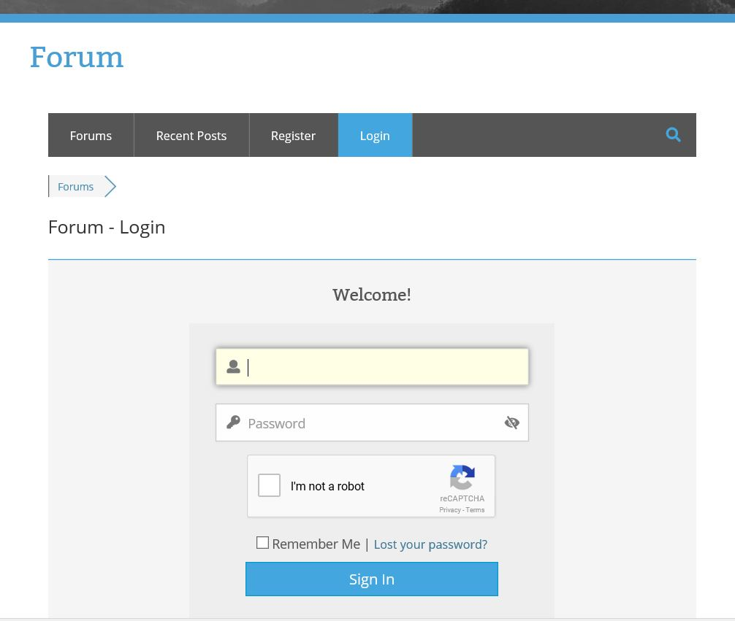

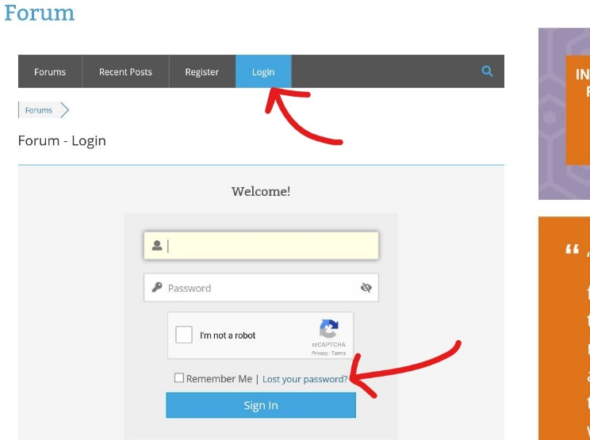
Step 2: Click “Lost your password” (see picture to the right).
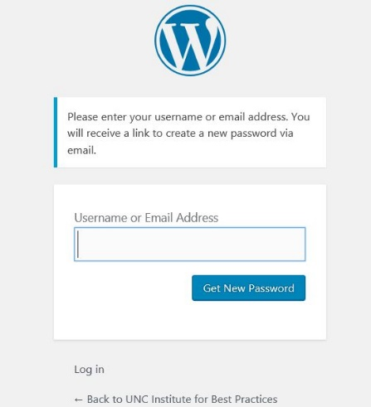
Then enter your email here (see picture below). Be sure it is the same email you used to register for the ACT listserv (that is what is saved in the system). Check your email – you should receive an email with a link (you need to copy and paste it – for whatever reason, doesn’t come as hyperlink to click).
Here is what the email will say: “Someone has requested a password reset for the following account: Site Name: UNC Institute for Best Practices Username: LornaLynnTest If this was a mistake, just ignore this email and nothing will happen. To reset your password, visit the following address: http://www.institutebestpractices.org/wp-login.php?action=rp&key=so7fjpbMfkcYJ3ZjXWEn&login=LornaLynnTest”

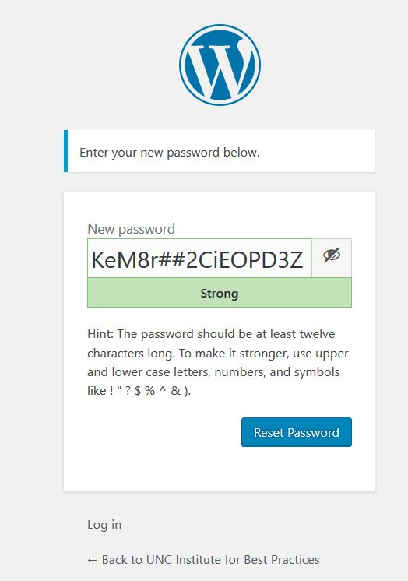
Step 3. When you copy and paste in above link from email, you will be taken here (picture to the right) – where a horribly long and complex password is offered. On this page, replace the auto-generated password with something you can remember. Once you submit your new password, the below shows up (don’t recommend clicking “Log In” at this step – see Step 4a below for more information. Recommend pasting in link in Step 4b).
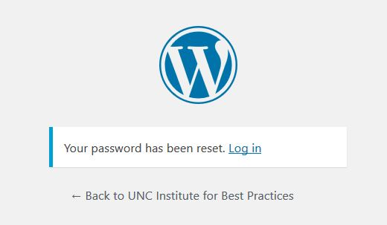

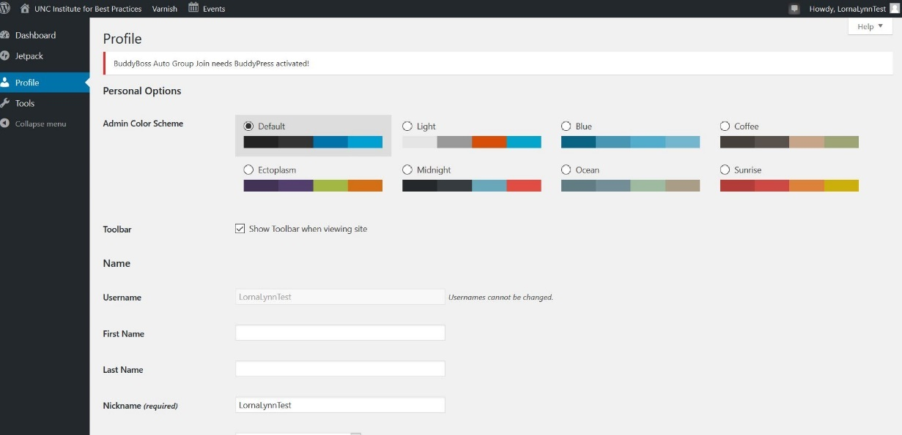
Step 4a. THIS IS WHERE THINGS CAN GET CONFUSING! If you log in at the above step, you will see this (right pic). You are basically logged in as a member of WordPress. You can navigate where you want to go by clicking “Dashboard” up in upper left corner, which takes you to our Institute home screen where you can then click on Forum Member Login (See Step 1, but now you have a password).

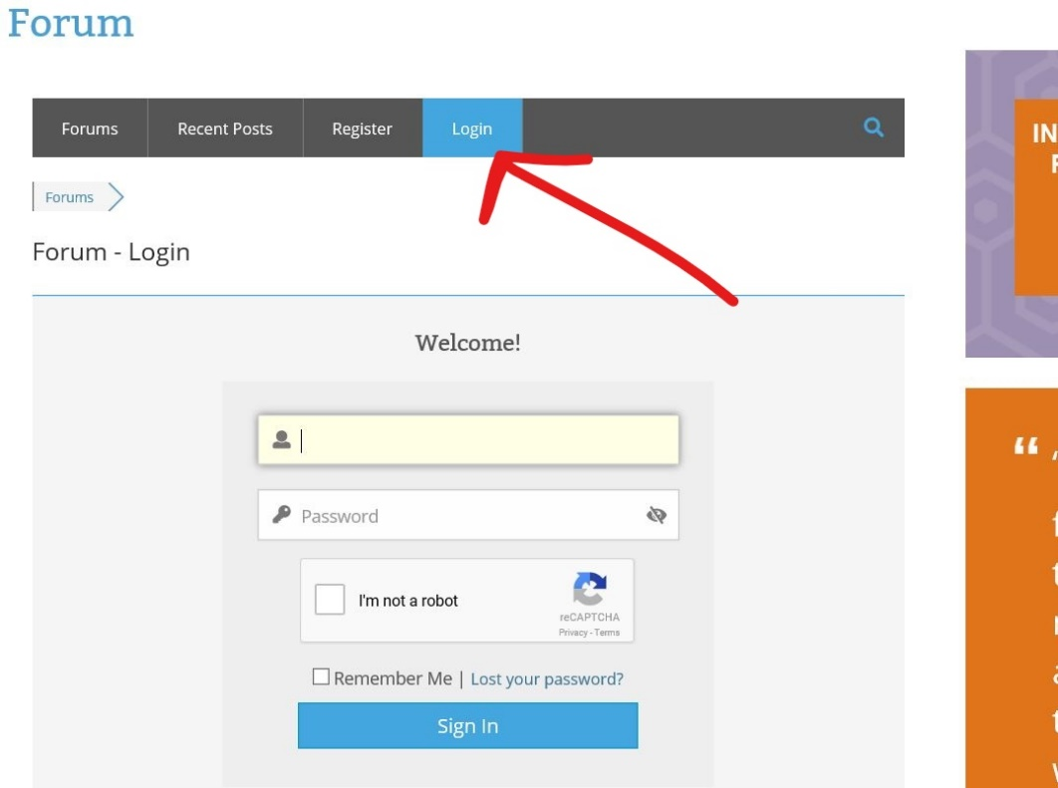
Step 4b. I recommend that you do not click the WordPress “Log in” link that shows up at Step 3, which then gets you to the page pictured in Step 4a. Instead go here: http://www.institutebestpractices.org/community/?wpforo=signin
Login with your email and new password you created.

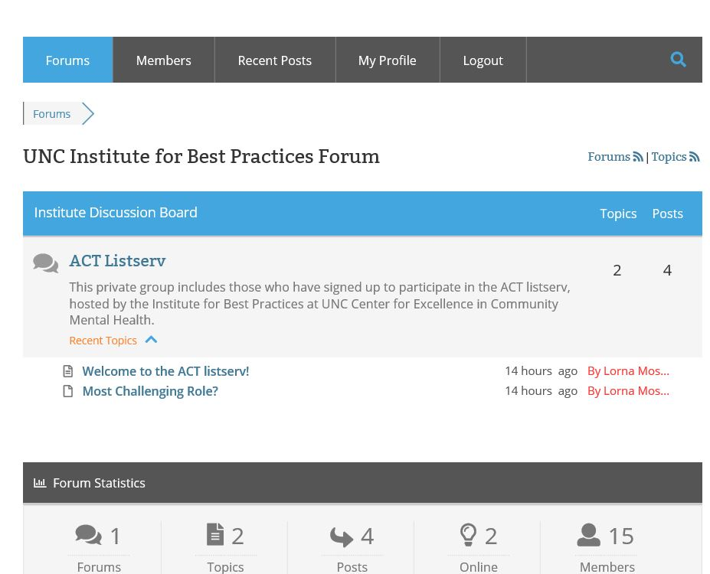
Step 5. Navigating the ACT Listserv Forum. We are assuming you are now logged in to the Forum. Yay! Here is what you should be seeing. For some people, you may become a member in more than one forum group on our site (e.g., NC ACT Coalition); you will then see more than one Forum group listed. For now, you likely only see the “ACT Listserv.” If you click on “ACT Listserv,” you will then be “in” the Discussion Forum.

Step 6. Once you have clicked on “ACT Listserv,” you see existing topics (you can then click on to read, or add to the discussion), and you can add a new topic to generate a new discussion topic (Click “Add Topic”).
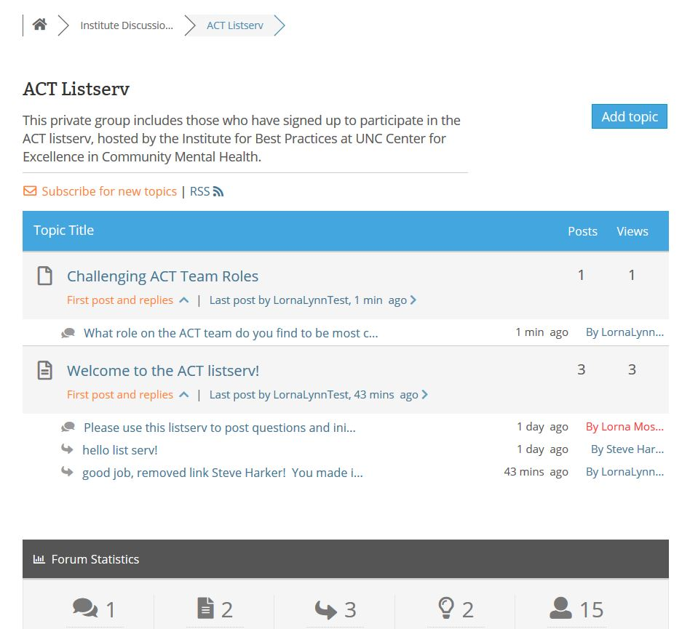

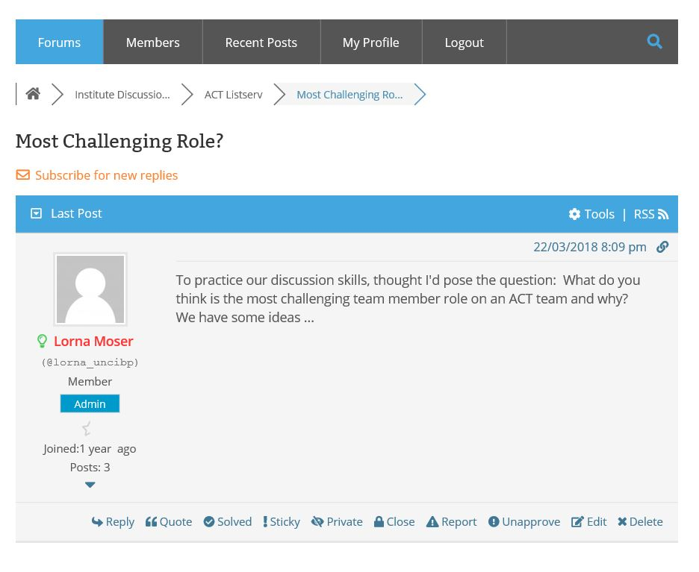
Step 7. Navigating within Forum. The upper menu is how you can easily navigate within. When you go into a topic, you can back up out of this one topic by clicking on “ACT Listserv,” or if there are multiple Forum groups you eventually belong to, you would click on “Institute Discussion Board” to back up further.

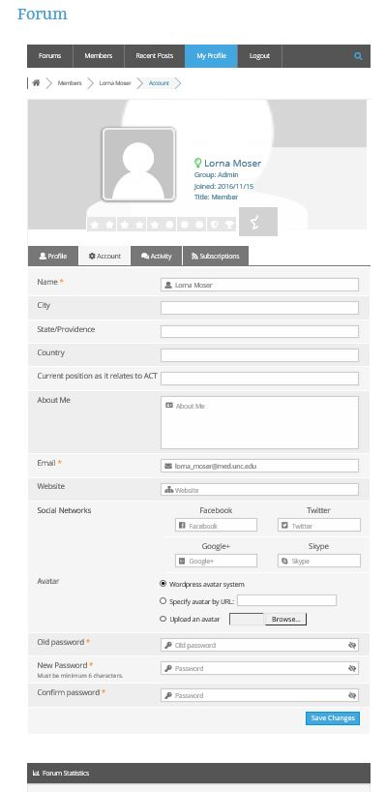

Step 8. Update your profile. We are relying on you to want to share a little about WHO you are by updating your profile, which is something that will be viewable by all Forum members. If you click “My Profile,” you can add those updates. Please make sure to “Save Changes!”

Email me directly if you are having problems – I will do my best to help out.
Lorna_moser@med.unc.edu

