UNC Research Study: Horyzons

Horyzons is a moderated social media and online learning platform for individuals living with mental illness. The platform is a place for you to talk to other individuals with similar experiences, vent, and learn new strategies for managing everyday life—all with the support of a team of therapists and peer support specialists.

If you are eligible and decide to participate in our research study, you will be involved in the study for approximately 12 months. It will involve an orientation to the Horyzons platform, access to the social media site, opportunity to meet people from other programs around the state, and optional virtual meet-ups.

Upon completion of the onboarding visit, you will be compensated $20 for your time and its completion. There will be about 50 individuals with first episode psychosis on the platform. To join our study is voluntary, and you may choose not to participate—or to withdraw your consent to be in the study—for any reason, and without penalty.

Below is a sneak peek at what the platform looks like.

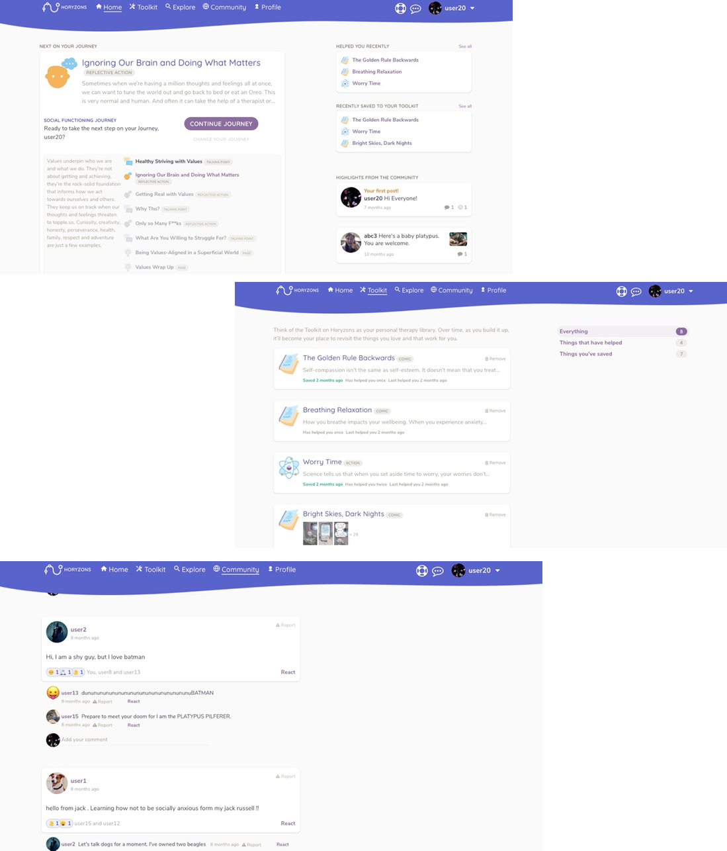
Horyzons Platform Examples

