Digital Specialist Manual

Data Collection Schedule
Data Form | Schedule
Referral, Admission, Admission Clinical Review, Discharge | As needed
Quarterly Clinical Review | - Quarterly
Vitals | - Program entry  - Quarterly
Labs | - Program entry  - Annually
Wellness (Relapse) Planning | - Initial plan developed within first year  - Review of plan annually
Program Feedback | - Six months  - Twelve months  - Annually
Service Delivery | - Quarterly

Accessing REDCap Surveys

- Click on “Add / Edit Records” on left hand side of REDCap homepage under “Data Collection”
- Search for client using client REDCap ID
- Navigate to client homepage. Should look like this:
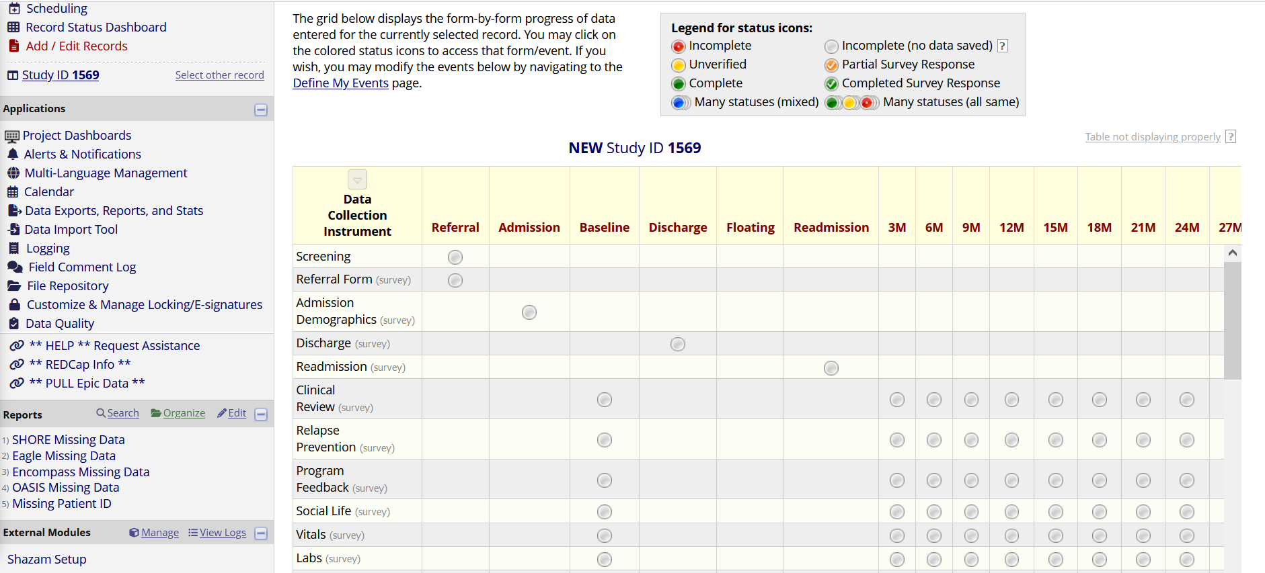
- Click on the bubble for the form and timepoint you are trying to access the survey for
** You cannot send the survey by copying and pasting the URL from this page. This is not the survey; it is just the form within REDCap.
- Once the form is open, click “Survey options” on the right side of the form
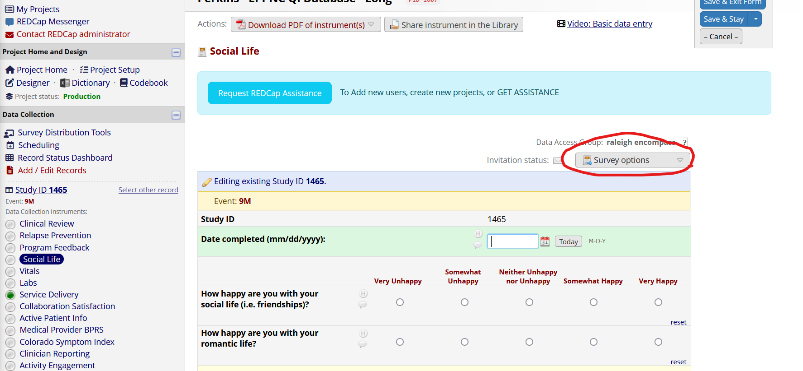

- From here, there are a couple of options:
  - “Open survey” and copy and paste the link wherever you need (text messages for clients or more personal emails to team members)
  - “Compose survey invitation” allows you to directly email survey out. Must enter the email of the person you are wanting to send to.
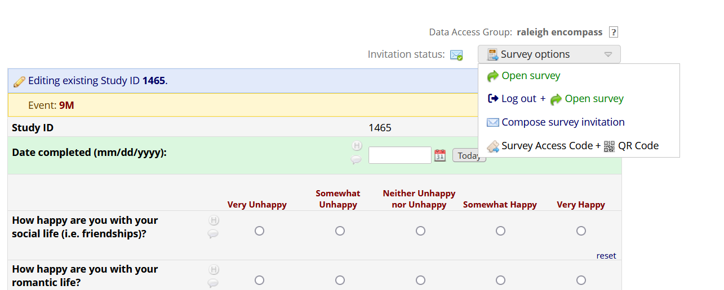

Creating new REDCap records
- Click on “Add/Edit Records” or “Record Status Dashboard”
- Click button for “Add New Record”
- Click bubble to open “Screening Form”
- Assign the new record to the appropriate clinic by looking on the right side above the data form, going next to “Assign record to a Data Access Group?” and clicking the drop-down for “Select a group.” Select your clinic.
- Enter the ID used by your clinic to identify clients in the “Client ID” text box, and the contact info for your team lead and digital specialist in those boxes.
- Go to “Form Status” at the bottom of the form, click the drop-down saying “Incomplete” and select “Complete” once you’re done entering data
- The record is now ready for intake forms to be entered
