Digital Navigator Data Collection Schedule and REDCap Overview

Data Collection Schedule
Data Form | Schedule for Completion
Referral | - Completed when referrals are reviewed
Admission Demographics | - Completed for all intake appointments
Admission Clinical Review | - Completed for all admitted clients
Discharge | - Completed when client is discharged
Quarterly Clinical Review | - Quarterly (end of each quarter)
Vitals | - Admission (vitals can be from 3 months before intake until 6 weeks after)  - Quarterly
Labs | - Admission (labs can be from 1 year before intake until 6 months after)  - Annually
Wellness (Relapse) Planning | - First year  - Annually
Program Feedback | - First year  - Annually
Service Delivery (sent to Clinical Data Coordinator) | - Quarterly

Accessing REDCap Surveys

- Click on “Add / Edit Records” on left hand side of REDCap homepage under “Data Collection”
- Search for client using client REDCap ID
- Navigate to client homepage. Should look like this:
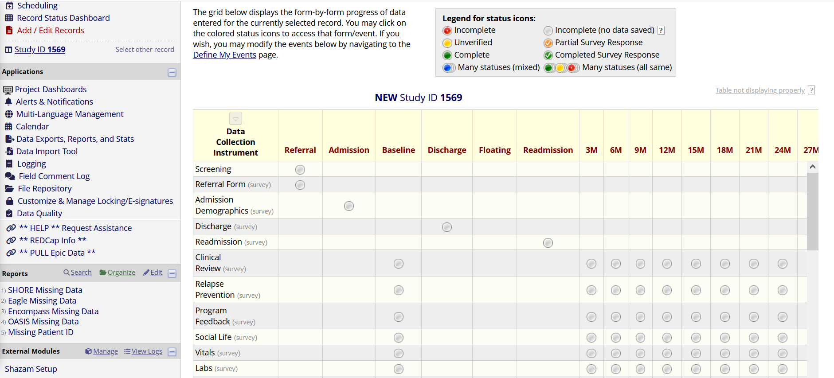
- Click on the bubble for the form and timepoint you are trying to access the survey for
** You cannot send the survey by copying and pasting the URL from this page. This is not the survey; it is just the form within REDCap.
- Once the form is open, click “Survey options” on the right side of the form
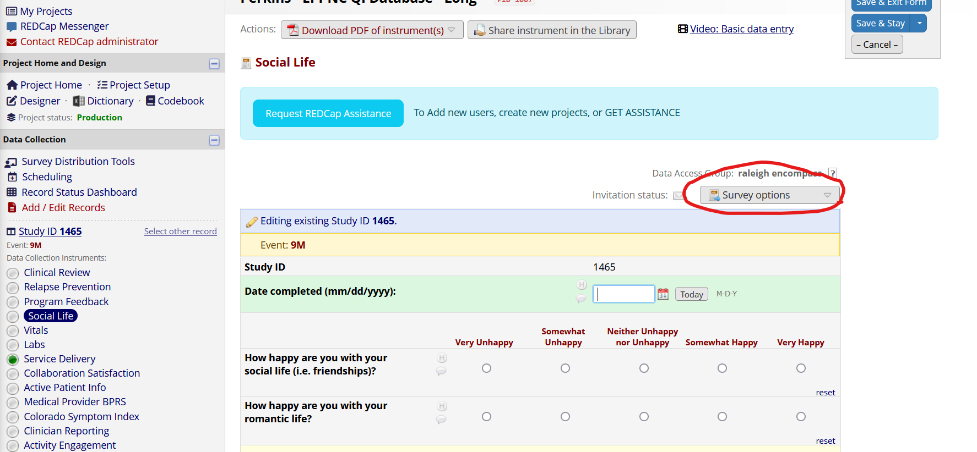

- From here, there are a couple of options:
  - “Open survey” and copy and paste the link wherever you need (text messages for clients or more personal emails to team members)
  - “Compose survey invitation” allows you to directly email survey out. Must enter the email of the person you are wanting to send to.
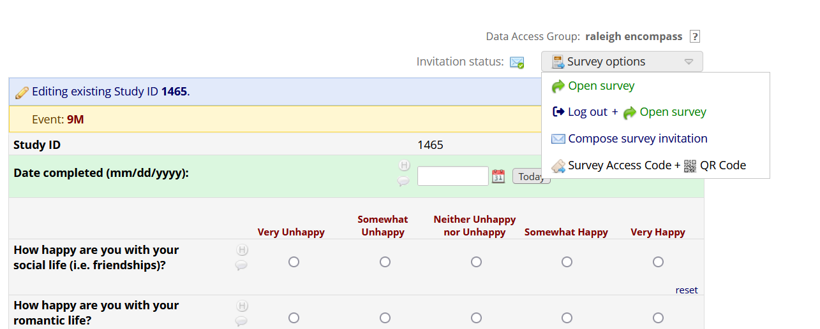

Creating new REDCap records
- Click on “Add/Edit Records” or “Record Status Dashboard”
- Click button for “Add New Record”
- Click bubble to open “Screening Form”
- Assign the new record to the appropriate clinic by looking on the right side above the data form, going next to “Assign record to a Data Access Group?” and clicking the drop-down for “Select a group.” Select your clinic.
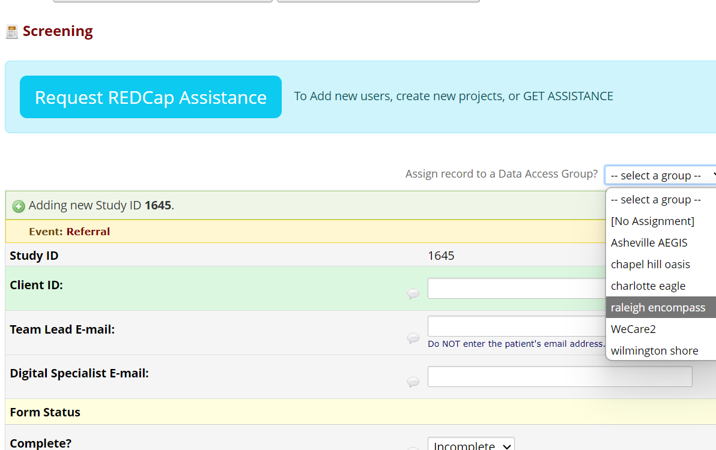
- Enter the ID used by your clinic to identify clients in the “Client ID” text box, and the contact info for your team lead and digital specialist in those boxes.
- Go to “Form Status” at the bottom of the form, click the drop-down saying “Incomplete” and select “Complete” once you’re done entering data
- The record is now ready for intake forms to be entered

If you forgot to assign the new record to a Data Access Group when completing the Screening Form, you can go to that person’s record page to assign it by clicking “Choose action for record,” then selecting “Assign to Data Access Group,” and choosing the appropriate CSC location.

