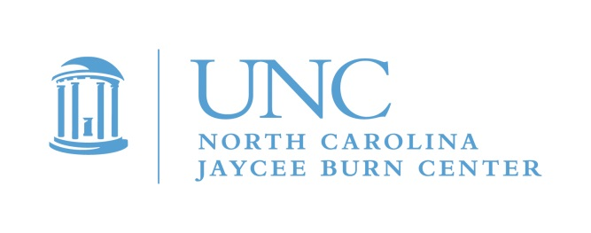
Camp Celebrate 2018
May 18-20, 2018

January 31, 2018

Dear Parents,

This is an invitation for your child to participate in a special weekend of camp! Camp Celebrate is a unique camp experience for children ages 7-15 who have experienced a burn injury. It will take place at Camp Kanata, in Wake Forest, NC and is free of charge to pediatric burn survivors.

Throughout the years, burn survivors have reported that their most meaningful support comes from other survivors. Camp Celebrate, which started in 1982 for a group of twelve young burn patients at the North Carolina Jaycee Burn Center, gives young survivors the opportunity to be with other young survivors. While most campers are treated at the Burn Center, Camp Celebrate welcomes any pediatric burn survivor in North Carolina and surrounding states. Activities include swimming, canoeing, arts and crafts, fishing, and much, much more! This year will be our 37th camp! WOW!
Camp Celebrate will offer your child the opportunity to meet other kids who share the experience of being a burn survivor. Every child, and many of the adult counselors, know exactly what it is like to have been through a burn injury. Campers develop meaningful friendships. Many campers come back year after year, some returning as adults to serve as camp counselors. These adults offer an understanding to the campers that no one else can.

This camp would not be possible without the continued dedication and support of MANY volunteers from across the state … college students, firefighters, Jaycees and Burn Center staff, to name a few. These generous individuals join the Burn Center Aftercare staff in providing campers a fun and enriching experience by serving as counselors, program staff, counselor-in-training mentors, and logistics assistants.

If you have never sent your child to Camp Celebrate, please consider it this year. As a parent, you may be amazed to discover how much your child benefits by simply being around other burn survivors, children and adults, who truly understand. Children that have skin that looks different may feel self-conscious about their scars and may feel more comfortable hiding them. We routinely hear stories from parents whose children came to camp that their child hid their scars before coming to camp but left empowered with a new sense of self-acceptance, scars uncovered! It is so inspiring to see!

Feel free to contact me directly to learn more. We are happy to discuss our program, put you in touch with other parents or answer any questions you have!

To sign up, just return the enclosed form right away. Once received, we will send you a full application for you to complete.

We look forward to hearing from you!

Michele Barr, Pediatric Aftercare Coordinator
Michele.barr@unchealth.unc.edu
919-962-8427

Applications are also available on our Web site: www.med.unc.edu/burn
PLEASE respond by March 20, 2018. Completed applications must be received by May 1, 2018!!

