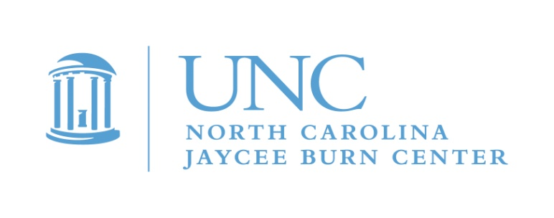

Announcing…

CAMP CELEBRATE 2018!

May 17-20, 2018

You are invited to apply to become a Counselor in Training (CIT) for CAMP CELEBRATE 2018

Campers are burn survivors ages 7-15, and CIT’s must be 16, 17, or 18 and still in high school.

Please consider joining us for a weekend of traditional fun camp activities while meeting other burn survivors your own age. Be an important part of the oldest burn camp in the United States!
This event is free for all campers and CIT’s! Camp is held at the YMCA’s Camp Kanata in Wake Forest, NC. This is our 37th year of camp, and we will have a star wars theme.

You are receiving this invitation because you have been a camper at CAMP CELEBRATE before or because we really want you to get involved now! We can only take a limited number of CITs, and we will interview all candidates. If this opportunity isn’t for you, that’s ok! We will be inviting you to teen camp in August where you can still be a camper.

CIT’s are a very important part of this exciting weekend, bridging the gap between camper and counselor. This is a great time to take on some responsibility, learn about leadership, become a role model and build your resume. We will give you the training and support you need to have a great time while making a difference in the lives of younger burn survivors. You know what it’s like to have a burn injury, so this means you are uniquely qualified to help the younger kids. This does require missing 2 days of school. Most schools are very supportive of this opportunity, and we are happy to contact them.

To request a CIT application, please complete and mail in the response card or download the CIT application found on the North Carolina Jaycee Burn Center website
https://www.med.unc.edu/burn/burn-programs/aftercare-programs-temp/camp-celebrate-1/camp-celebrate
You can also e-mail me and I will send the link or forms to you!
If you or your parents have any questions, please contact me for more information
Michele Barr, Pediatric Aftercare Coordinator
Michele.barr@unchealth.unc.edu
919-962-8427
Please respond by April 1st. Completed applications are due May 2!

