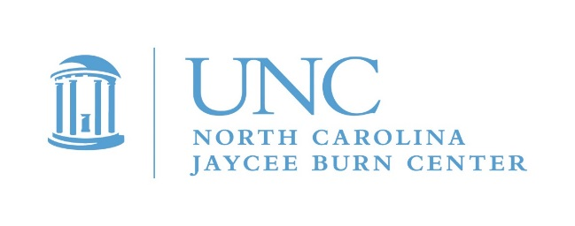
Greetings from the Burn Center! A new year brings renewed excitement for our flagship pediatric program, Camp Celebrate. With a Star Wars theme, we celebrate that the force has been with us for 37 years now! Camp Celebrate is an amazing opportunity to help pediatric burn survivors connect with each other, feel supported and learn how to adjust to their burns or skin differences. As a volunteer, you can expect a lot of fun, an action packed schedule, limited sleep and heart touching memories. Recruitment efforts are underway for a top notch Camp Celebrate volunteer crew and you are invited to submit an application.
Volunteering for Camp Celebrate is a big responsibility. You will directly impact the lives of the campers as well as your fellow volunteers. Each year the Burn Center has had to become increasingly structured and advanced in the way we recruit, select and train volunteers. There is huge liability involved when it comes to those who have direct access to children. We are dedicated to the safety of children at all of our events. This means we are required to complete an orientation, background, and reference checks annually. New volunteers will undergo an interview process.
Volunteer application submission will close on April 1, and possibly earlier if we fill our positions. However, one of the single biggest ways you can help us out is to submit your application just as soon as you know you can join us. Please submit your application ASAP if you are available to help us provide the best camp possible for our young burn survivors. We want, and need, for you to be a part of Camp Celebrate 2018!
Volunteer commitment for Camp Celebrate will be May 17-20, 2018 for volunteers. Mandatory volunteer orientation will be on Thursday, May 17. Although we get requests for exceptions, it is essential that every volunteer attend orientation each year for our liability and training purposes. There will be a wrap up on Sunday, May 21, so please plan to be at camp until at least 1:30pm.
Camp counselors remain our most important asset and greatest need. If you have been a counselor for several years and are interested in being a cabin leader, let us know! We are looking for positive and responsible individuals who want to make a difference in the lives of children. We hope you will apply!
We are not accepting any new volunteers for the logistics team. However, we would like to grow our photo/tech/video support team.
For an application, please email Maria Albani at maria_albani@med.unc.edu. For more information contact Michele Barr at Michele.barr@unchealth.unc.edu or (919) 962-8427. (If you are no longer interested in receiving these emails, please reply and you will be promptly removed.)
Camp Celebrate is an incredible experience for campers and volunteers alike. We promise that what you get back will be far greater than what you give!
We hope to see you at Camp!
The Aftercare Team

