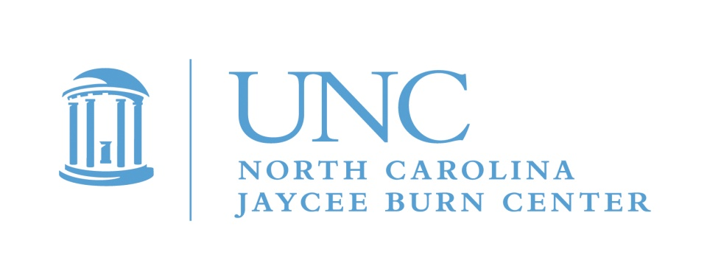
June 2019

Dear Teen Burn Survivor,

The North Carolina Jaycee Burn Center’s Aftercare Program would like to invite you to Teen Adventure Weekend 2019! The adventure will happen August 16-18, 2019 at Camp Don Lee, near Arapahoe, NC. This active weekend camp is for burn survivors, ages 13-18, who have not yet graduated high school. This is a free event! This camp is totally different from Camp Celebrate, so if you have never attended our teen only event, and have questions, please let me know. This year we will be going to another new location, and chartering a bus to get there. We have a new camp to explore, and it has lots to offer, including waterfront views and sailing! This will be an active weekend with lots of water activities.

Teen Adventure Weekend provides the opportunity for teen burn survivors to hang out and have fun with other teens who understand what it is like to have a burn injury as well as develop some useful life skills. As you grow and mature, you may discover that your burn has affected you in ways that you have not experienced before. Teens have told us that it really makes a difference to meet and talk with others their own age that know what it’s like to have been burned. You will see old friends, meet new ones, and maybe try some things you may not have done before! Whether your burn was large or small, recent or a long time ago, you are welcome to join us for the fun.

Space is limited to 24 campers, so sign up NOW if you are interested! Registration deadline is July 15, 2019. Every year we have a waiting list for this event, and we do expect to fill up before the deadline. The first step is to request or print an application form. The first 24 teens to return completed applications to us can look forward to a great weekend at Teen Camp. We like to split the spots evenly between males and females to the extent possible. If you go on a waiting list, we will let you know if a space opens. If you are interested in joining the adventure, return your application to:

Teen Adventure Weekend attn.: Michele Barr
North Carolina Jaycee Burn Center
UNC Hospitals
101 Manning Drive, CB #7600
Chapel Hill, North Carolina 27599-7600

If you have any questions or to request an application, please give me a call or e-mail! 919-962-8427 or Michele.barr@unchealth.unc.edu. We are looking forward to hearing from you. The drop off and pick up location will be at The Friday Center in Chapel Hill, NC. If it is closer for you to meet us at the camp in Arapahoe, we can communicate to arrange this. The directions, packing list and other details will be mailed after we get your registration application. We hope you will join us for another great camp!

Michele

Michele Barr,LRT/CTRS
Pediatric Aftercare Coordinator
The North Carolina Jaycee Burn Center
Fax: (984) 974-1870

