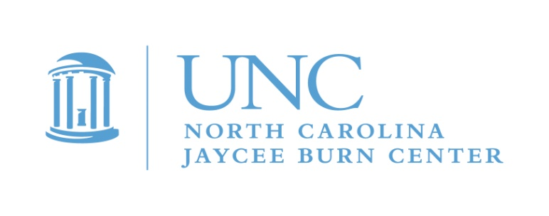

Announcing…
Camp Celebrate 2020

Burn Aftercare is now accepting applications for the Counselor in Training (CIT) role for
CAMP CELEBRATE 2020.

You are receiving this invitation because you have either had burn injury, have been admitted to our burn center for other reasons, or have previously been a camper at CAMP CELEBRATE . Whatever your story is, we invite you to get involved now!

CIT’s are a very important part of this exciting weekend, bridging the gap between camper and counselor. This is a great time to take on some responsibility, learn about leadership, become a role model and build your resume. We will give you the training and support you need to develop leadership skills while you have a great time making a difference in the lives of younger burn survivors. You know what it is like to have a burn injury, so this means you are uniquely qualified to help the younger kids.

CIT’s must be 16, 17, or 18 and still in high school and, if accepted, must commit to attending mandatory orientation on May 14 and participating in all of CAMP CELEBRATE, including volunteer wrap up on Sunday afternoon, May 17. This does require missing 2 days of school. Most schools are supportive of this volunteer opportunity, and we are happy to communicate with them, if needed. We can provide a letter also.

Please consider joining us for this weekend of traditional fun camp activities while meeting other burn survivors your own age. Be an important part of CAMP CELEBRATE, the oldest burn camp in the United States! This event is free for all campers and CIT’s! Camp takes place at the YMCA’s Camp Kanata in Wake Forest, NC. This is our 39th year of camp, and it just keeps getting better!

We can only take a limited number of CITs, and we will interview all candidates. If this opportunity is not for you, it is ok! We will be inviting you to teen camp in August.

To request a CIT application, please complete and mail in the response card by March 1st.
You can also e-mail me and I will send the website link or forms to you! If you or your parents have any questions, please contact us for more information. CIT spaces are limited. DO NOT WAIT! APPLY NOW!
I look forward to hearing from you!
Michele
Michele Barr, Aftercare Coordinator
Michele.barr@unchealth.unc.edu
919-962-8427
Please return card by March 1st if interested. Completed applications are due April 1! Interviews must be scheduled and completed before April 15th.

