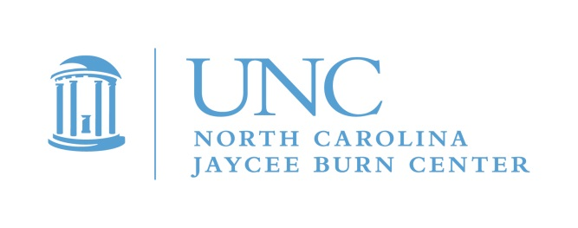

Dear Parents or Guardians,

This is an invitation for your child to participate in a special weekend of camp! Camp Celebrate is a unique camp experience for children ages 7-15 who have experienced a burn injury. It will take place at Camp Kanata, in Wake Forest, NC and is free of charge to pediatric burn survivors. The dates for camp are September 11th, 12th and 13th.

Throughout the years, burn survivors have reported that their most meaningful support comes from meeting other people who know what it’s like to have burns. Camp Celebrate, which started in 1982 at the North Carolina Jaycee Burn Center, gives young survivors the opportunity to be with other burn survivors. Camp Celebrate welcomes any pediatric burn survivor in North Carolina and surrounding states. Activities include swimming, canoeing, arts and crafts, fishing, and much, much more! This year will be our 39th year of camp. We will be planning another exciting themed camp this year.
Camp Celebrate will offer your child the opportunity to meet other kids who share the experience of being a burn survivor. Every child, and many of the adult counselors, know exactly what it is like to have been through a burn injury. Campers develop meaningful friendships. Many campers come back year after year, some return as adults to serve as camp counselors. These adults offer an understanding to the campers that no one else can.

This camp would not be possible without the continued dedication and support of MANY volunteers from across the state … college students, firefighters, Jaycees and Burn Center staff, to name a few. These generous individuals join the Burn Center Aftercare staff in providing campers a safe, fun, and enriching experience by serving as counselors, program staff, counselor-in-training mentors, and logistics assistants.

If you have never sent your child to Camp Celebrate, please consider it this year. As a parent, you may be amazed to discover how much your child benefits by simply being around other burn survivors, both children and adults, who truly understand. Children that have skin that looks different may feel self-conscious about their scars and may feel more comfortable hiding them, or deny that their scars bother them. We routinely hear stories from parents that their child hid their scars before coming to camp but left empowered with a new sense of self-acceptance, scars uncovered! It is so inspiring to see. You might be surprised how much your child has to gain from a weekend camp experience.

Feel free to contact me directly to learn more. We are happy to discuss our program, put you in touch with other parents or answer any questions you have.

To sign up, just return the enclosed form right away, or email me to request an application. Next, we will send you a full application for you to complete.

We look forward to hearing from you!

Michele Barr, Pediatric Aftercare Coordinator
Michele.barr@unchealth.unc.edu
919-962-8427

Applications are also available on our Web site: www.med.unc.edu/burn
PLEASE respond by July 15, 2020. Completed applications must be received by August 21, 2020!!

