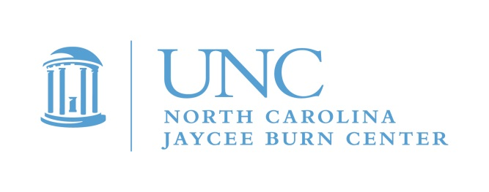

January 23, 2023

Dear Parents and/or Guardians and potential Counselors in Training (CIT’s),

The North Carolina Jaycee Burn Center’s Aftercare Program is excited to invite all teenage burn survivors between the ages of 16-18 to participate in a unique camp! Camp Celebrate is a camp for burn survivors and will take place at Camp Kanata, in Wake Forest, NC. Camp Celebrate is free of charge to pediatric burn survivors. Camp Celebrate will be held May 18-21, 2023.

Camp Celebrate started in 1982 at the North Carolina Jaycee Burn Center to give burn survivors the opportunity to be with other kids and adults who have also experienced burns. Camp Celebrate welcomes any pediatric burn survivor in North Carolina and surrounding states. Activities include swimming, canoeing, arts and crafts, fishing, and much more! This year we look forward to returning to a weekend long event.
Camp Celebrate offers teens who are still in school, but have not graduated, the opportunity to remain involved with camp in a very important role different from being a camper. For many years younger campers watch the CIT’s, and aspire to be one. The younger kids love engaging with the older teens, and it is amazing how it impacts both campers and CIT’s. We want to encourage teens interested in learning and service to join our camp leadership program. CIT’s learn basic skills for working with the younger campers under the mentorship of some of our most experienced staff. The overall purpose is to have fun and connect, while learning important life and leadership skills, as we continue to build our community of burn survivors.

If you have never been a part of Camp Celebrate, you can still join us as a CIT. You will find a group eager to welcome you! People that have skin that looks different may feel self-conscious about their scars and may feel more comfortable hiding them. Others have physically healed, but have reminders of the trauma or challenges of the burn. Teenagers often are concerned about body image, fitting in, and expressing their unique differences in an often stressful world. Camp provides an opportunity for fun as well as empowerment. Often teens gain a new sense of self-acceptance, connection, or purpose - knowing that they are not the only ones to have skin differences or to have been through a traumatic experience. The other teens in the CIT program understand this, because they are all burn survivors too. Feel free to contact me directly to learn more. We are happy to discuss our program, put you in touch with other parents or answer any questions you have.

We do have another camp for teenagers every summer, to join us as a camper. Teen Adventure Weekend is our summer teen camp, stay tuned for more information about that event.

If you are interested in joining our CIT Program, just return the enclosed form right away, call or email me to request an application. Next, we will send you a full application for you to complete. Once the completed application is received, we schedule your interview.

We look forward to hearing from you!
Michele

Michele Barr, Aftercare Coordinator
Michele.barr@unchealth.unc.edu
919-962-8427

Applications are also available on our Web site: www.med.unc.edu/burn
PLEASE respond by March 15, 2023. Completed applications must be received by April 15th, 2023!!

