**Step 1**: Click on “*Add Order*” to get to the Ambulatory Referral Form (see example below).



**Step 2**: In the search box, type in *“Ambulatory Referral to Cardiothoracic Surgery”* or use Code: REF13.

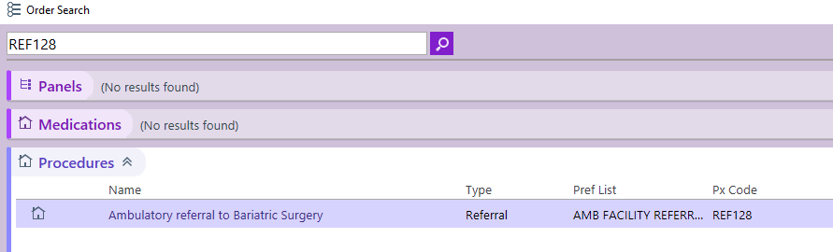

**Step 3**: Click on the hyperlink for *Ambulatory Referral to Cardiothoracic Surgery* to open the referral window.

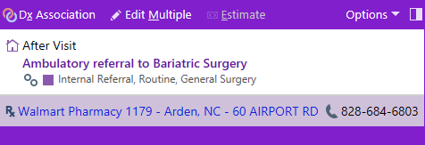

.

**Step 4:** Standard information will default (as seen below). Make the following selection in the To Dept:

* UNCH Adult Cardiac Surgery Chapel Hill

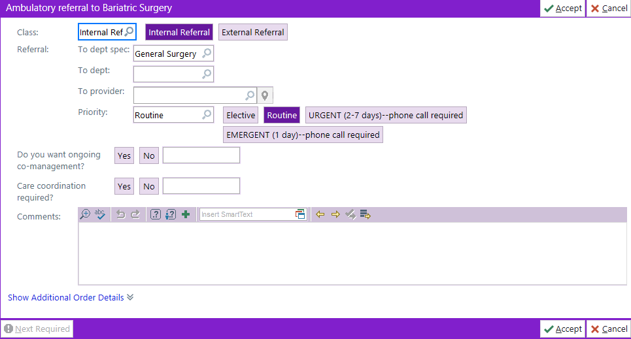

**Step 5**: Complete additional information as needed, including selecting a specific referred to provider.

* If unable to find provider, you many need to change the search location to Chapel Hill.

***For Referrals Outside of Epic Call:***

Office: 984-974-2900; ***please*** **ask for CT Surgery** to provide guidance for ANY type of referral