**Step 1**: Click on “*Add Order*” to get to the Ambulatory Referral Form (see example below).



**Step 2**: In the search box, search for *“Ambulatory Referral* *to Bariatric Surgery*” or use Code: REF128.

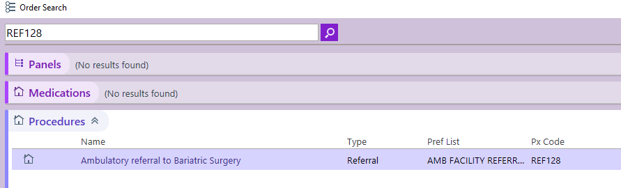

**Step 3**: Click on the hyperlink, “*Ambulatory Referral to Bariatric Surgery*” to open the referral window.

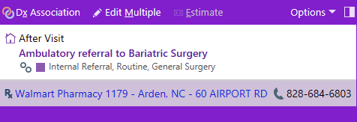

**Step 4:** Standard information will default (as seen below). Make the following selection in the To Dept:

* UNCH Multispecialty Surgery
* UNC General & Bariatric Surg. Hillsborough

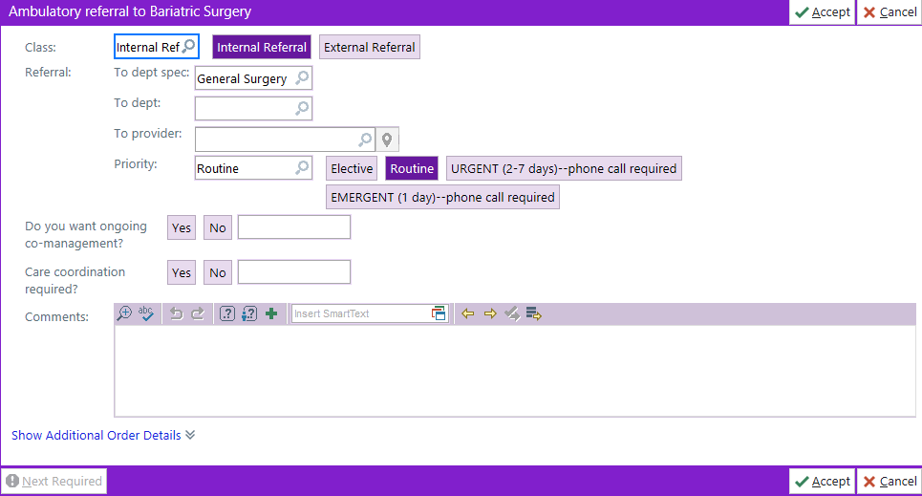

**Step 5**: Complete additional information as needed, including selecting a specific referred to provider.

*Note: if unable to find provider, you may need to change the search location to Chapel Hill, NC*

***For Referrals Outside of Epic Call***

Office: 984-974-6519 | Fax: 919-590-6372