**Step 1**: Click on “*Add Order*” to get to the Ambulatory Referral Form (see example below).



**Step 2**: In the search box, type in *“Ambulatory Referral to GI Surgery”* or use **Code: REF149**

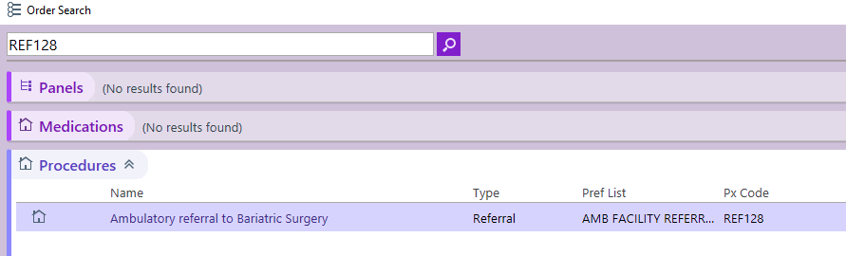

**Step 3**: Click on the referral hyperlink *“Ambulatory Referral to GI Surgery”* to open the referral window.

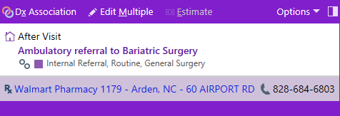

.

**Step 4:** Standard information will default (as seen below). Make the following selection in the To Dept:

* UNCH Multispecialty Surgery GU Surgery Chapel Hill

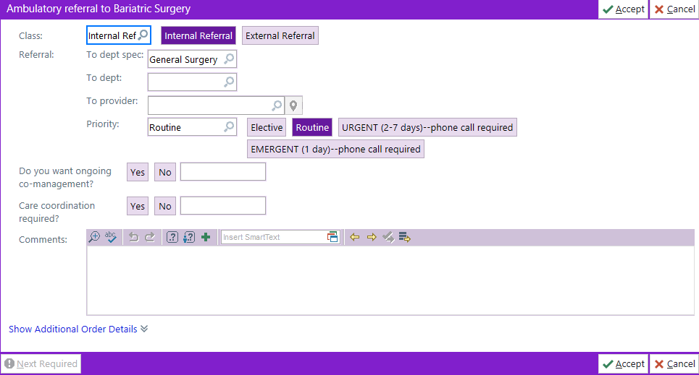

**Step 5**: Complete additional information as needed, including selecting a specific referred to provider.

* If unable to find provider, you many need to change the search location to Chapel Hill.

***For Referrals Outside of Epic Call or Fax:***

Office: 984-974-0150 | Fax: 919-590-6372