**Step 1**: Click on “*Add Order*” to get to the Ambulatory Referral Form (see example below).



**Step 2**: In the search box, search for *“Ambulatory Referral* *to Pediatric Surgery”* or use the Codes.

Pediatric Referral Codes

Cardiothoracic: REF113

Plastics: REF117

General: REF84

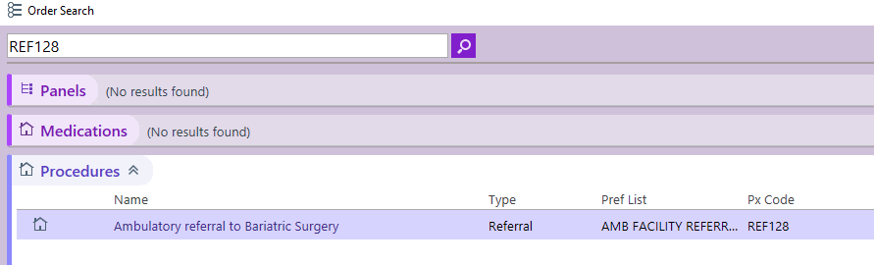

**Step 3**: Click on the hyperlink, “*Ambulatory referral to* *Pediatric Surgery*” to open the referral window.

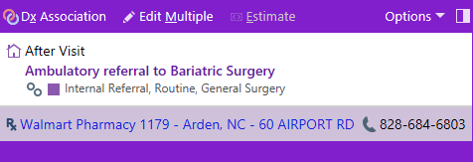

**Step 4:** Standard information will default (as seen below). Make the following selection in the To Dept:

* UNCH Children’s Cardiothoracic Surgery Chapel Hill
* UNCH Children’s Plastic Surgery Chapel Hill
* UNCH Children’s General Surgery Chapel Hill

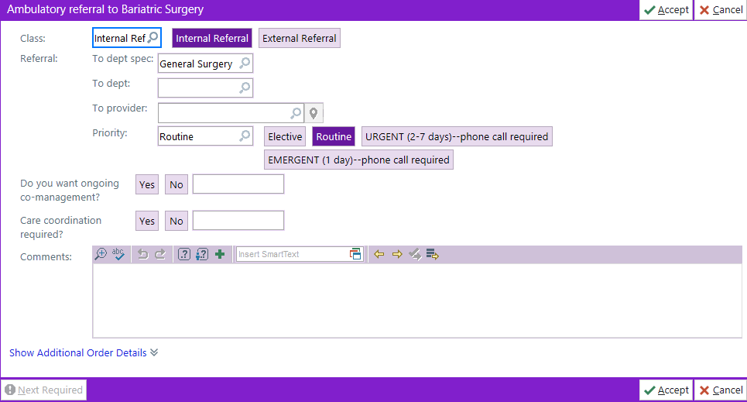

**Step 5**: Complete additional information as needed, including selecting a specific referred to provider.

* If unable to find provider, you many need to change the search location to Chapel Hill.

***For Referrals Outside of Epic Call or Fax:***

Office: 984-974-1401 | Fax: 9919-843-2497