**Step 1**: Click on “*Add Order*” to get to the Ambulatory Referral Form (see example below).



**Step 2**: In the search box, search for *“Ambulatory Referral* *to Plastic Surgery*” or use **Code REF89**

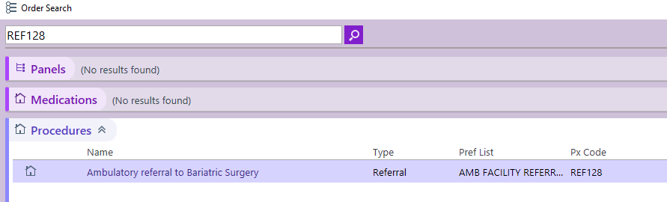

**Step 3**: Click on the hyperlink, “*Ambulatory Referral to Plastic Surgery*” to open the referral window.

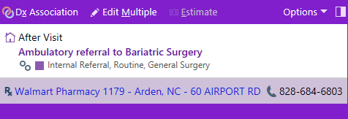

.

**Step 4:** Standard information will default (as seen below). Make the following selection in the To Dept:

* UNC Plastic and Reconstructive Surgery at Vilcom Center
* UNC Plastic Surgery at Panther Creek Chapel Hill

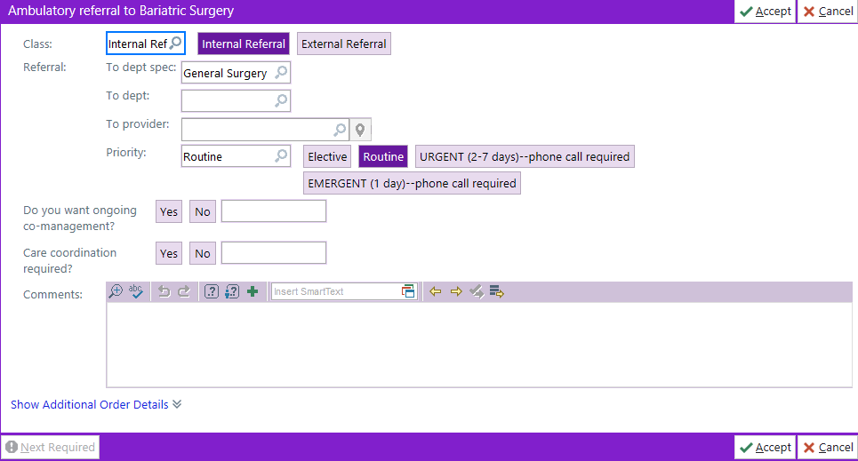

**Step 5**: Complete additional information as needed, including selecting a specific referred to provider.

* If unable to find provider, you many need to change the search location to Chapel Hill.

***For Referrals Outside of Epic Call***

Office: 984-215-6350