**Step 1**: Click on “*Add Order*” to get to the Ambulatory Referral Form (see example below).



**Step 2**: In the search box, search for *“Ambulatory Referral* *to Surgical Oncology*” or use Code: REF56.

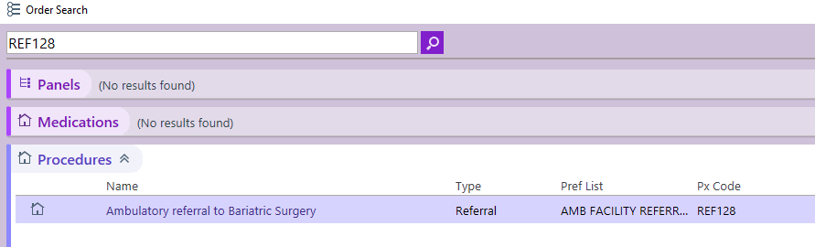

**Step 3**: Click on the hyperlink, “*Ambulatory Referral to Surgical Oncology”* to open the referral window.

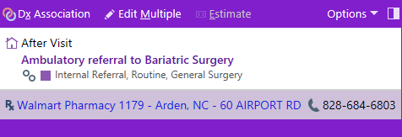

**Step 4:** Standard information will default (as seen below). Make the following selection in the To Dept:

* UNCH Surg. Onc. Chapel Hill
* UNC Surg. Onc. Hillsborough

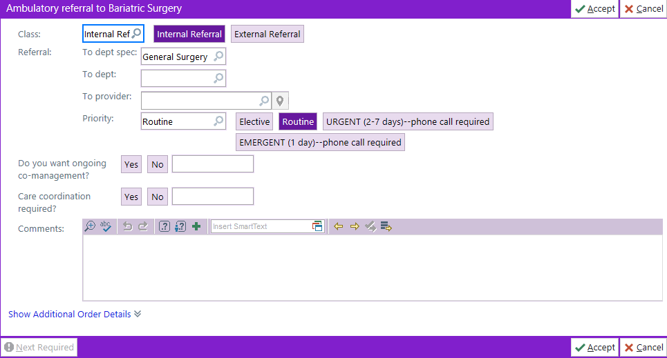

**Step 5**: Complete additional information as needed, including selecting a specific referred to provider.

***For Referrals Outside of Epic Call***

Breast Cancer > Office: 984-974-8116

GI/Melanoma (Last names: A-G) > Office: 984-974-9189

GI/Melanoma (Last names: H-O) > Office: 984-974-8463

GI/Melanoma (Last names: P-Z) > Office: 984-974-8289

Endocrine > Office: 984-974-8622