**Step 1**: Click on “*Add Order*” to get to the Ambulatory Referral Form (see example below).



**Step 2**: In the search box, search for *“Ambulatory Referral* *to*……” or use the Referral Code.

Transplant Referral Codes

Cardiology: REF13

Pulmonary: REF501

Nephrology: REF502

Hepatology: REF503

Abdominal: REF259

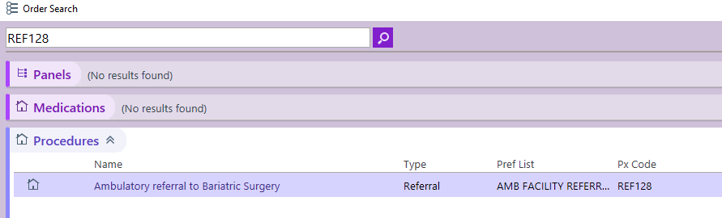

**Step 3**: Click on the hyperlink, “*Ambulatory Referral to* …….” to open the referral window.

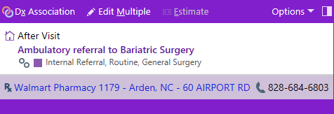

**Step 4:** Standard information will default (as seen below). Make the following selection in the To Dept:

* UNCH Heart Transplant & LVAD Chapel Hill | UNCH Cardiology Eastown | UNCH Multispecialty
* UNC Lung Transplant Chapel Hill
* UNCH Kidney Transplant Chapel Hill
* UNCH Liver Transplant Chapel Hill

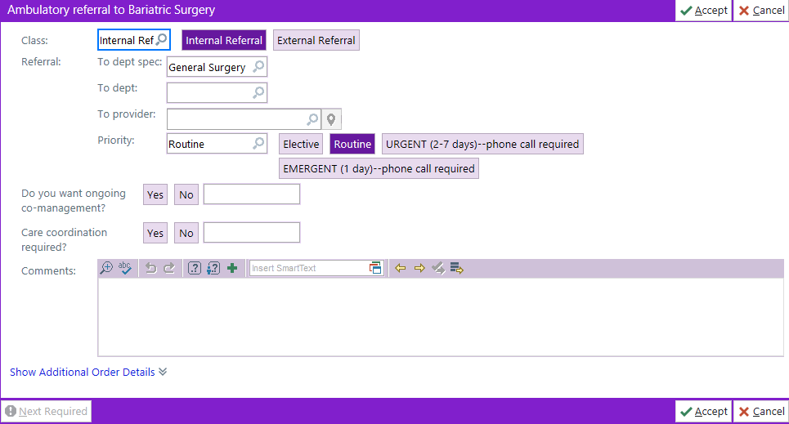

**Step 5**: Complete additional information as needed, including selecting a specific referred to provider.

* If unable to find provider, you many need to change the search location to Chapel Hill.

***For Referrals Outside of Epic Call or Fax:***

Pulmonary Transplant > Office: 984-974-9098 | Fax: 984-974-6822

Cardiology Transplant > Office: 984-974-2900 | Fax: 984-974-7738

Nephrology Transplant > Office: 984-974-5200 | Fax: 984-974-0888

Hepatology Transplant > Office: 919-966-2516 | Fax: 919-966-3414