**Step 1**: Click on “*Add Order*” to get to the Ambulatory Referral Form (see example below).



**Step 2**: In the search box, search for *“Ambulatory Referral to……”* or use the Referral Code.

Referral Codes

General Surgery: REF27

Hernia Surgery: REF129

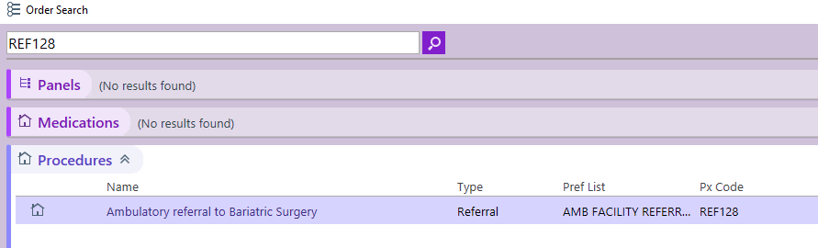

**Step 3**: Click on the referral hyperlink, “*Ambulatory Referral to*….” to open the referral window.

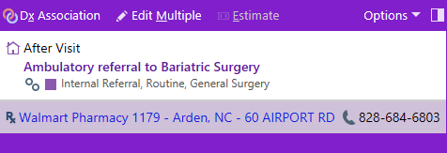

.

**Step 4:** Standard information will default (as seen below). Make the following selection in the To Dept:

* UNC Gen and Acute Surg 101 Manning Dr Chapel Hill or UNC General and Bariatric Surgery Hillsborough
* UNC Hernia Center Chapel Hill

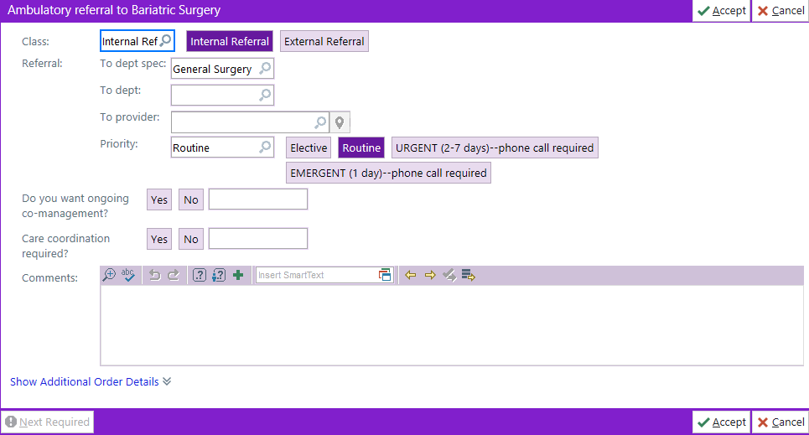

**Step 5**: Complete additional information as needed, including selecting a specific referred to provider.

* If unable to find provider, you many need to change the search location to Chapel Hill.

***For Referrals Outside of Epic Call or Fax:***

Office: 919-966-4389 | Fax: 919-966-0369