**Step 1**: Click on “*Add Order*” to get to the Ambulatory Referral Form (see example below).



**Step 2**: In the search box, search for *“Ambulatory Referral* *to Vascular Surgery*” or use the Code: REF108

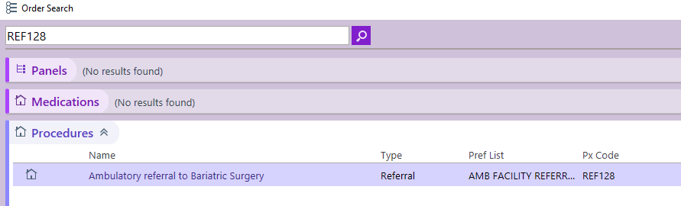

**Step 3**: Click on the hyperlink, “*Ambulatory Referral to Vascular Surgery*” to open the referral window.

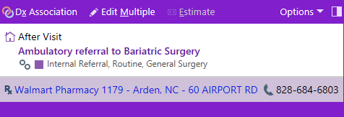

**Step 4:** Standard information will default (as seen below). Make the following selection in the To Dept:

* UNCH Heart Vascular CTR Surgery Meadowmont Chapel Hill
* UNCH Vascular Surgery Chapel Hill

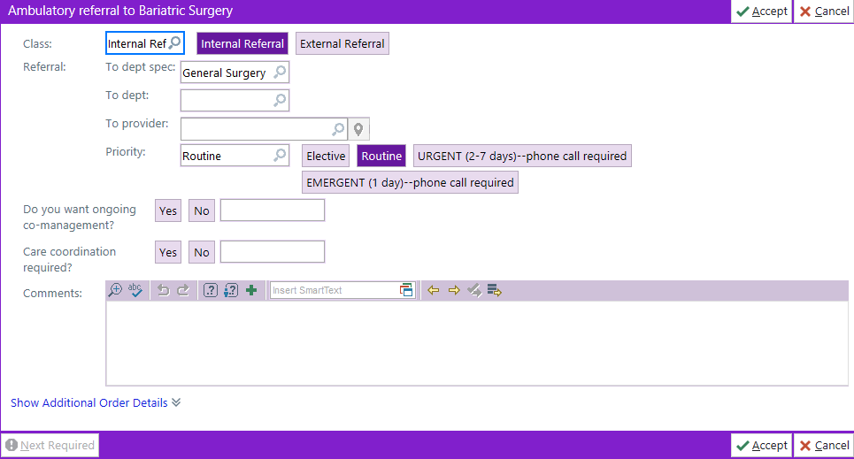

**Step 5**: Complete additional information as needed, including selecting a specific referred to provider.

* If unable to find provider, you many need to change the search location to Chapel Hill.

***For Referrals Outside of Epic Call:***

Referral Center: 984-974-5662