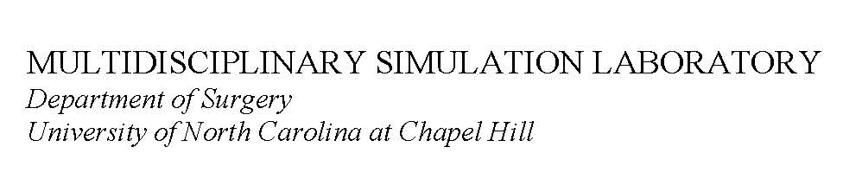
MULTIDISCIPLINARY SIMULATION LABORATORY
Department of Surgery, University of North Carolina at Chapel Hill
Neal Murty, Manager
Office: (919) 962-3125
Cell phone: (910) 724-3138
Email: neal_murty@med.unc.edu

Simulation Lab Request Form
(Please fill out this form, save it, and email it to Neal Murty at neal_murty@med.unc.edu)

So that we can provide the best service possible, please make your request at least 2 weeks in advance, especially if you are requesting pig products for your class.

Date of request: ___________________________ Date for your lab session: ________________________

Client name: ______________________________________________________________________________________________

Department / vendor name: __________________________________________________________________________________

Contact information: Phone: ________________________________ E-mail: _________________________________

Simulation service requested (check boxes): ☐CABG ☐AVR ☐MVR ☐Aortic root ☐Heart dissection ☐Aortic cannulation
☐Vessel anastomosis ☐Chest tube insertion ☐VATS ☐Thoracotomy ☐Thoracentesis ☐Tracheostomy
☐Central line insertion ☐Arterial line insertion ☐A-fib ablation technique ☐Bronchoscopy ☐Laryngoscopy
☐Practice using laparoscopic instruments ☐Suture class using pigs’ feet.
☐Other: ____________________________________________________________________________________________

Number of students in class: _________________ Do you have an instructor for the class? ___Yes ___No

If no, would you like us to contact an instructor for you? ___Yes ___No

Name(s) of your instructor (s):_______________________________________________________________________________

Type of product requesting (check boxes): ☐pig hearts ☐lungs ☐saphenous vein ☐trachea ☐esophagus ☐pig feet ☐pig skin

Amount of product needed: __________________________________________________________________________________

___________________________________________________________________________________________________________

Use of conference room: ☐Y ☐N Use of video system: ☐Y ☐N Use of OR: ☐Y ☐N Need staff for OR: ☐Y ☐N

Use of Visitor 1 communication system: ☐Y ☐N Use of Simulation Lab 1: ☐Y ☐N Use of Simulation Lab 2: ☐Y ☐N

Use of Simulation Lab 3: ☐Y ☐N

Specific instrumentation request: _________________________________________________________________________________________________________

__________________________________________________________________________________________________________

We cannot guarantee we will be able to borrow specialty instruments. It depends on caseloads for the date you are having your class.

Supplies needed for class: ☐Sutures ☐Drapes ☐Gowns ☐Gloves ☐Staple loads ☐Hemaclips ☐Harmonic scalpel ☐Prep sticks

(Please continue to page 2)

Do you need lunch provided: ☐Y ☐N What time will lunch be delivered? ____ Use of conference room for lunch: ☐Y ☐N

Which restaurant will be providing your food?_ _______________________________________________________________

Will you need hotel / restaurant reservations made for visiting guests? ☐Y ☐N

What restaurant, date and time would you like reservations for? ___________________________________________________

____________________________________________________________________________________________________________

Billing information:

Account number: _______________________________

Contact information for billing:

Name, Department: ___________________________________________________________________________________________

Phone: ____________________________________ E-mail: ______________________________________________________

Notes (if there’s anything else we need to know, please list it here):

