What you need to know about wearing the activity monitor

* **DOs:**
* **Do** remember to wear the monitor for one full menstrual cycle, approximately 1 month. After that, you will wear it for one week per month until you conceive or until after the sixth month, whichever comes first.



* **Do** be sure the monitor is worn on the elastic band around your wrist as shown.
* **Do** remove the monitor right before going to bed. Leave it on a table or dresser where you will be sure to see it first thing the next morning.



* **Do** put your monitor on each morning when you get out of bed.
* **Do** hand wash the monitor band in cold water and mild detergent if it becomes soiled.
* **DON’Ts:**
* **Don’t** let the monitor get wet. You should not wear it when you are bathing, showering, or swimming. Be sure to put it back on when you are out of the water.



* **Don’t** drop the monitor or knock it against hard objects.
* **Don’t** forget to wear the monitor every day for at least one full month. If you forget to put it on for any part of the day, put it on as soon as you remember. We can tell from the read-out as to whether or not it has been worn.



**MAKE SURE THE BLACK DISC ON THE MONITOR IS FACING YOUR FINGERS**

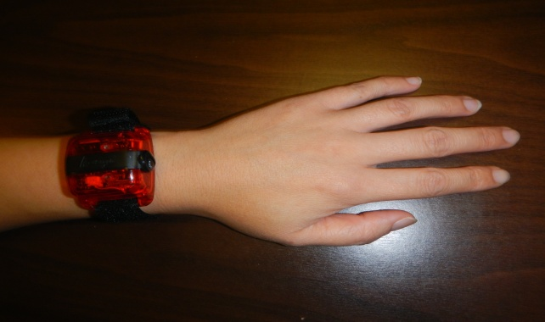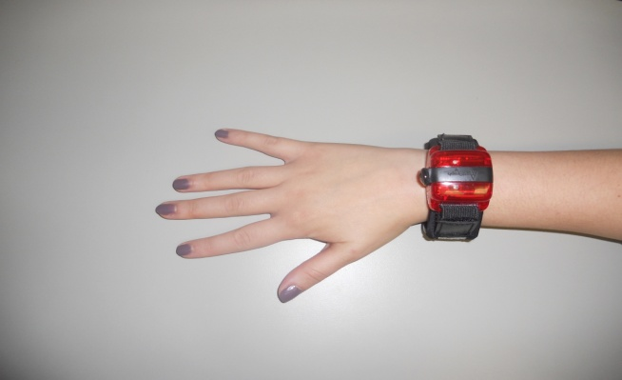

* **What to do if you have questions:**
* Call us at 919-843-8246. Weekend calls will be returned on Monday.



Thank you very much for your participation!