Ovulation Test Instructions
Please read the entire set of instructions before beginning to test. If you have any questions, please don't hesitate to contact us at 919-843-8246 or at fertility@unc.edu.
INTENDED USE
The ovulation tests are used to obtain quick visual, semi-quantitative results for early detection of Luteinizing Hormone (LH) in urine samples. The LH surge is used to predict a release of mature ovum within 24-48 hours.

WHEN TO TEST
First determine the length of your menstrual cycle. This is the number of days from the first day of menstrual bleeding to the day before the next bleeding starts again. Second, refer to the following chart to determine when you should start testing. The first day of bleeding is cycle day 1. Perform testing 6 days in a row or until the LH surge (darkest test line) has been detected.

Cycle length: | Start testing on:
25 days | day 9
26 days | day 10
27 days | day 11
28 days | day 12
29 days | day 13
30 days | day 14
31 days | day 15
32 days | day 16
33 days | day 17
34 days | day 18
35 days | day 19
SPECIMEN COLLECTION
- Use provided cup to collect a urine sample.
- Collect urine once per day. LH is synthesized during the day so best time to test is 10am to 8pm. DO NOT USE FIRST MORNING URINE.
- Make sure to test daily at approximately the same time each time you test.
- Specimen should be allowed to settle for 5 minutes and reach room temperature before testing.
TEST PROCEDURE
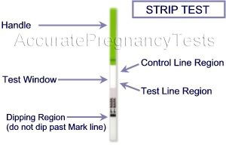
- Make sure the urine sample and unopened ovulation test are at room temperature prior to administering the test.
- Remove the test device from its protective pouch by tearing along a side notch.
- Hold the green plastic handle and immerse the test strip into the urine with the white absorbent arrow end pointing towards the sample. Make sure not to immerse past the maximum line marker. Take the strip out after 3 seconds and place it horizontally on a clean, dry, surface. Do not immerse for longer than 5 seconds. Allow 5 minutes to complete the test reaction.

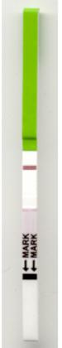

RESULT INTERPRETATION
Make sure to read test results at 5-minute mark. Reading too early or too late may yield incorrect interpretation of the results and may vary according to users experience.
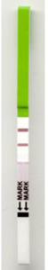
Negative Result
Only one color band appears on the top Control (C) region. There should be no apparent band on the Test (T) region. The control line is designed to validate the test and should be crisp and clear in intensity with white membrane background.
T C
Positive Result
Distinct and consistent color bands appear on the Control (C) and Test (T) regions. The intensity of test line is equal to or darker than the intensity of the control line.
T C
Invalid Results
Uncertain test results should be discarded in case there is no visible control line. Repeat test with a new test device.
NOTE: Listed below are some of the reasons why a surge may not be detected.
- Urine is collected at the wrong time of day, such as first morning urine, which should not be used.
- The concentration of LH is too low to accurately detect. If you are consistently experiencing this problem please contact your fertility specialist.
- Testing is performed too early or too late in the menstrual cycle. Refer to table in the PREPARATION section of the instructions to determine when to start testing.
- Testing is stopped before the surge occurs, and should have been continued for a few more days.
- A LH surge did not occur during this menstrual cycle, or was missed when testing.

