Individualization Phase Committee Meeting 2/14/2022
Introduction and agenda approval
Dr. Sellars on success of Science of Medicine: the ERAS track has worked out well, students presented work recently
Student updates: currently in block 12, many in electives/rotations, many working on rank lists, Match day coming up
Campus updates: no updates from any campuses
Mindy McKinney update on courses:
- 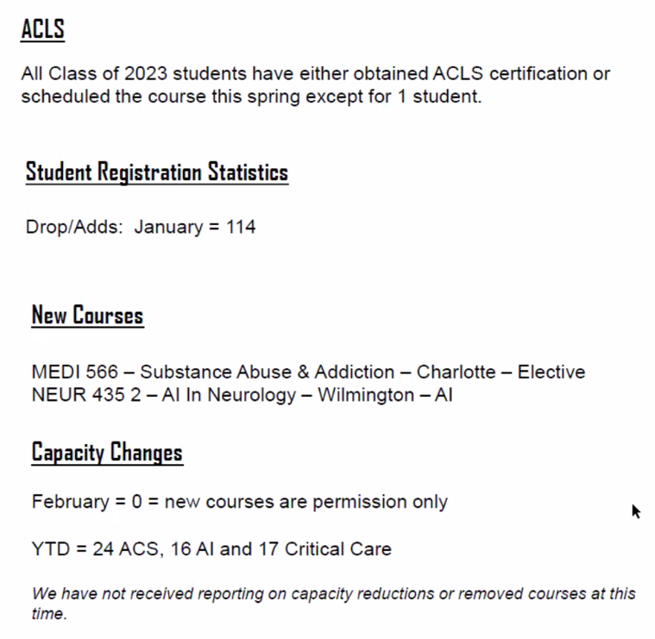
- New courses approved
Spotlight: Amber Chrismon from the Greensboro campus
Competency-based assessment: new SUPERSTAR mnemonic for evaluations, looking for any feedback on it
Cam Enarson on LCME update:
- Continual quality improvement
- Discussion of standard 9.5: narrative assessment (including a narrative description of a student’s performance on rotations), standard 9.7: formative assessment
- Required to provide this information: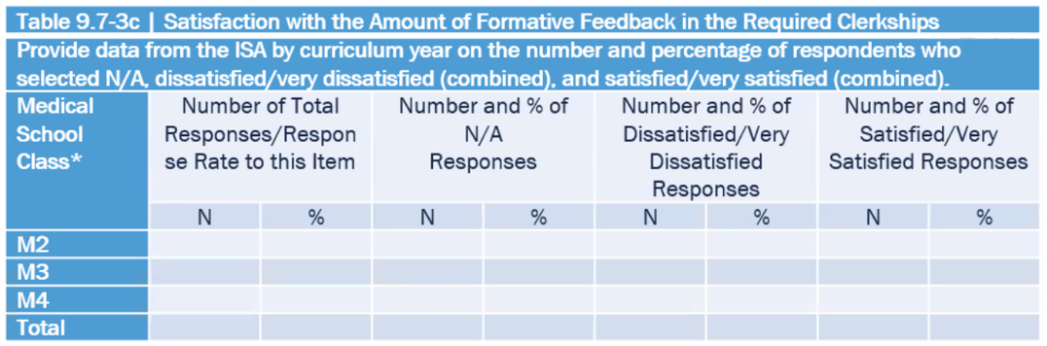
- Need to review student assessment policy and update Qualtrics forms to better obtain this information

